 UNIVERSITY COLLEGE OF ENGINEERING (BIT CAMPUS)
TIRUCHIRAPPALLI-620024

DEPARTMENT OF INFORMATION TECHNOLOGY
NAAN MUTHALVAN

SB8026 – ROBOTIC PROCESS AUTOMATION DEVELOPMENT

PROJECT TITTLE: SHOPPING HELPER BOT

SUBMITTED BY
JENCY SHAGAYA SALINI V-810022205076

GUIDED BY
Dr. M. PADMA



UNIVERSITY COLLEGE OF ENGINEERING(BIT CAMPUS)

TIRUCHIRAPPALLI-620024



ANNA UNIVERSITY, CHENNAI 2024- 2025
UNIVERSITY COLLEGE OF ENGINEERING(BIT CAMPUS)
TIRUCHIRAPPALLI-620024

DEPARTMENT OF INFORMATION TECHNOLOGY

Certified that this is a bonafied record of work done by
Mr./Ms_________________________Register No__________________________Of
Semester V during the academic year 2024-2025 in SB8026- ROBOTIC PROCESS
AUTOMATION DEVELOPMENT

Staff-in-Charge Head of the Department

Submitted for the University Practical Examinationd held in

INTERNAL EXAMINER EXTERNAL EXAMINER
TABLE OF CONTENT

- Project Definition
- Problem Statement
- Project Objectives
- Project Description
- Detailed Procedure with Screenshots
- Output Screenshot
- Weekly Session Content
- Diploma Certificate
- Conclusion
- Referance

SHOPPING HELPER BOT
1.PROJECT DEFINITION:
The Shopping Helper BOT is an AI-driven chatbot designed to enhance the online shopping experience by offering personalized product recommendations, helping users discover items based on preferences, providing price comparisons, assisting with order tracking, and informing users about discounts and promotions. The bot can be integrated into e-commerce platforms or operate independently, offering instant customer support for product inquiries, shopping cart management, and providing guidance throughout the shopping journey.
2.PROBLEM STATEMENT:
1.Extract all the available products from Flipkart.
2.filter the data.
3.ask the user to input a minimum and maximum price range.
4.Then, send the filtered data to the user's email.

3.PROJECT OBJECTIVES:
1. Improve User Experience: Make shopping easier with quick product discovery and personalized recommendations.
2. Automate Product Search and Comparison: Enable seamless product search and price comparison across multiple platforms.
3. Simplify Checkout and Order Tracking: Streamline the checkout process and provide real-time order updates.
4. Provide Instant Customer Support: Offer quick answers to product, payment, and shipping questions.
5. Offer Personalized Suggestions: Suggest products based on user preferences and shopping history.

4.PROJECT DESCRIPTION:
The Shopping Helper BOT is designed to assist users in finding and filtering products on Flipkart, specifically for iPhones, based on their budget preferences. It automates the entire process of extracting product details from Flipkart, applying filters based on user-defined price ranges, and delivering the results via email in an Excel file.This project leverages UiPath’s web automation, data manipulation, and email integration capabilities, making it an ideal example of a robotic process automation (RPA) solution for online shopping assistance.
Features:
- Web Scraping: The bot extracts details of iPhone products from Flipkart, including names, prices, and additional product details.
- User Interaction: The bot allows users to specify a minimum and maximum price range as well as their email address.
- Data Filtering: It filters the extracted product data based on the user's budget constraints.
- Report Generation: The filtered data is saved into an Excel file for easy reference.
- Email Delivery: The bot emails the Excel file to the user, completing the process seamlessly.

5.DETAILED PROCEDURE WITH SCREENSHOT:
Step1:Enter the name of the project:
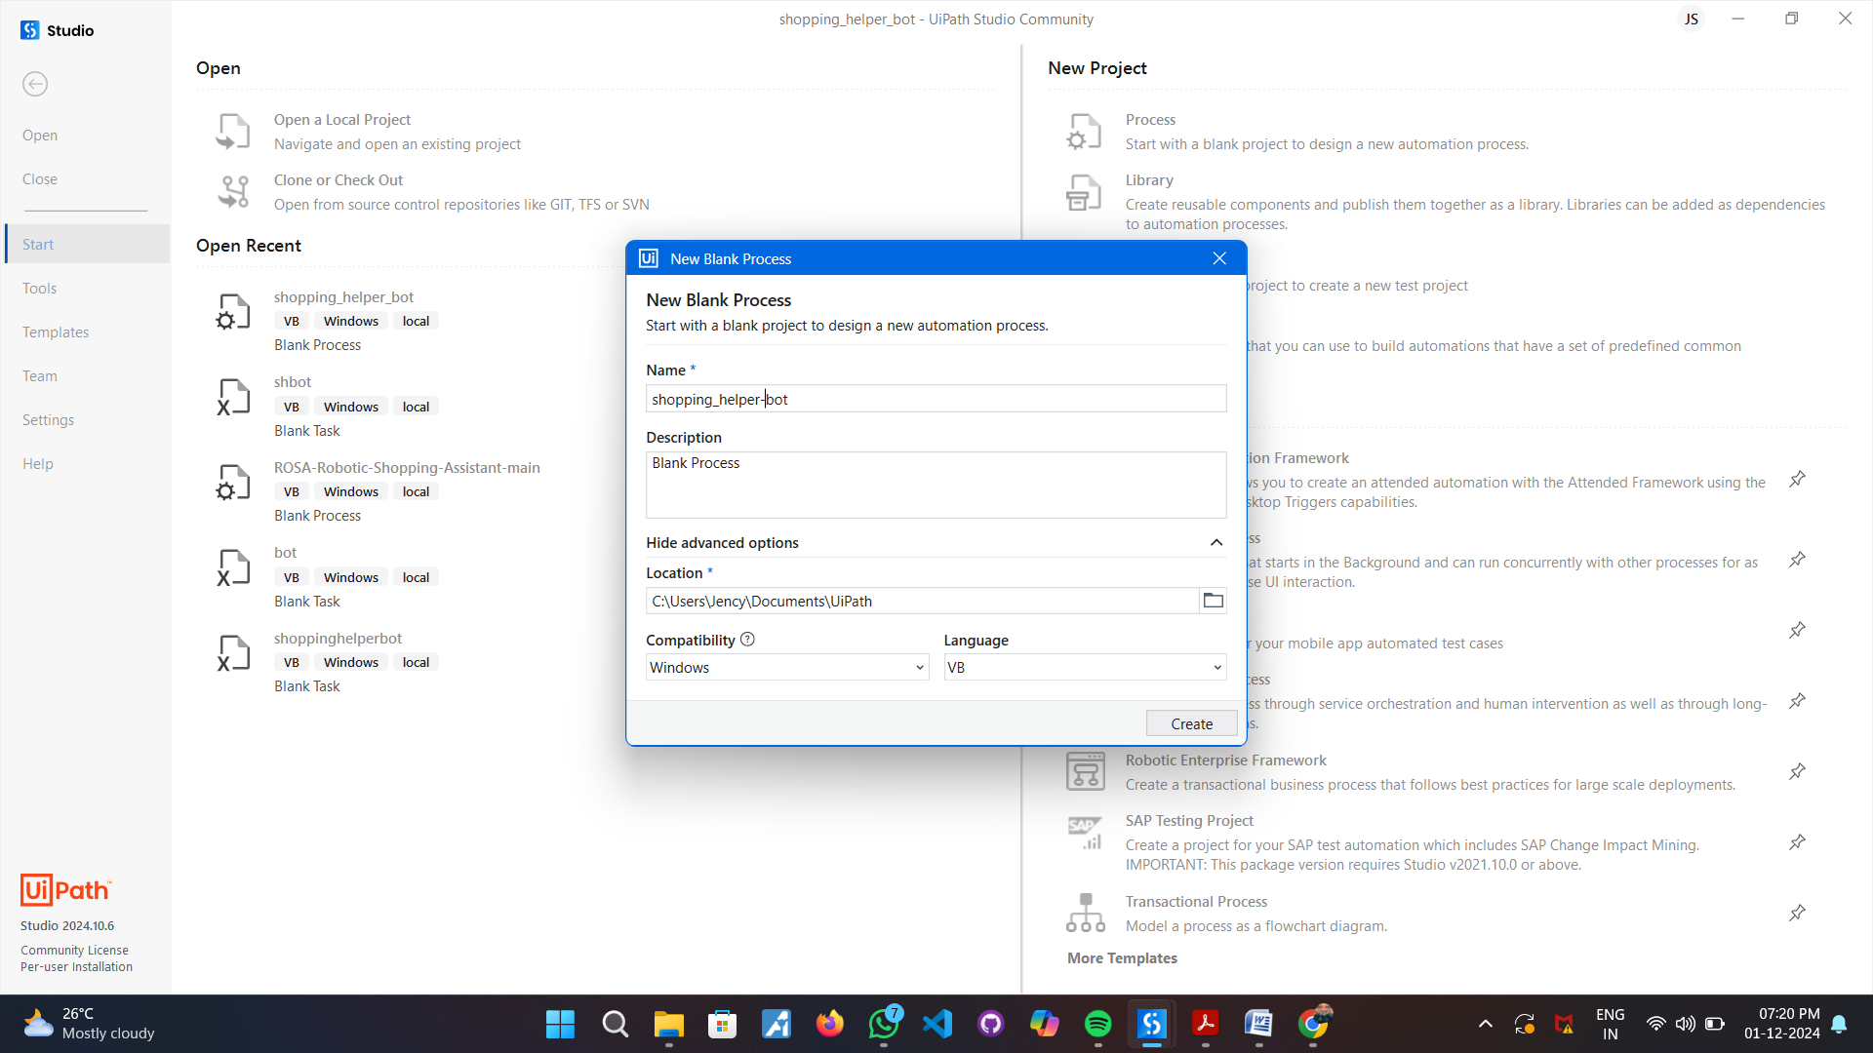
Step 2: Open Flipkart and Search for Products:
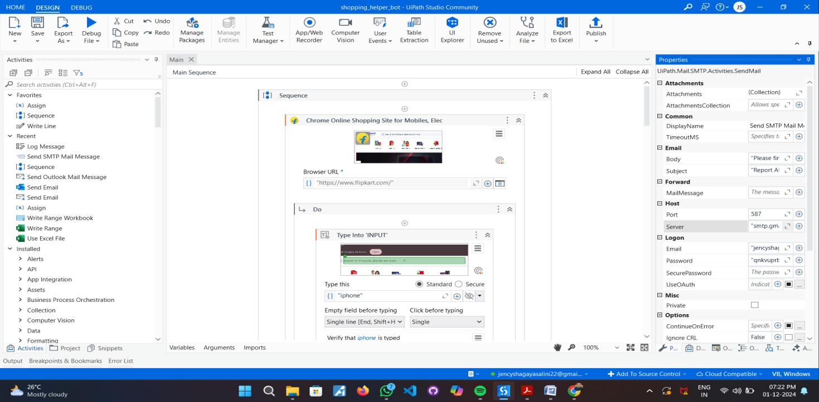

Step 3: Use the Type Into activity to search for "iPhone" in the Flipkart search bar and Add a Click activity to press the search button:
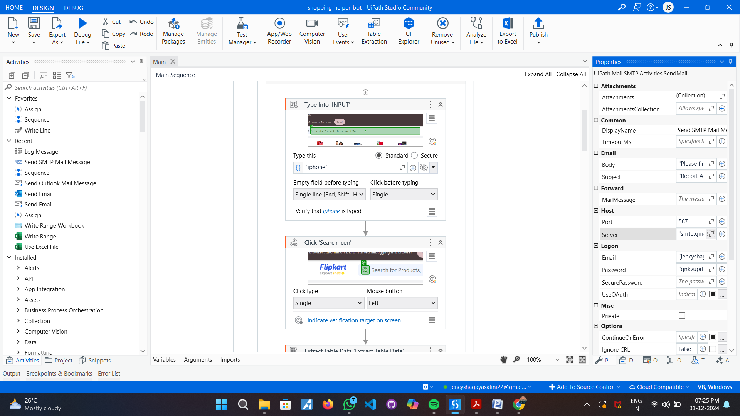

Step 4: Extract Product Data:

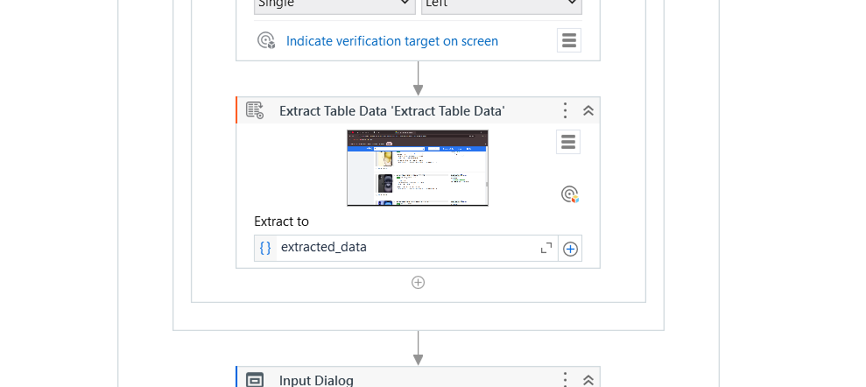

Step 5: Get User Input:

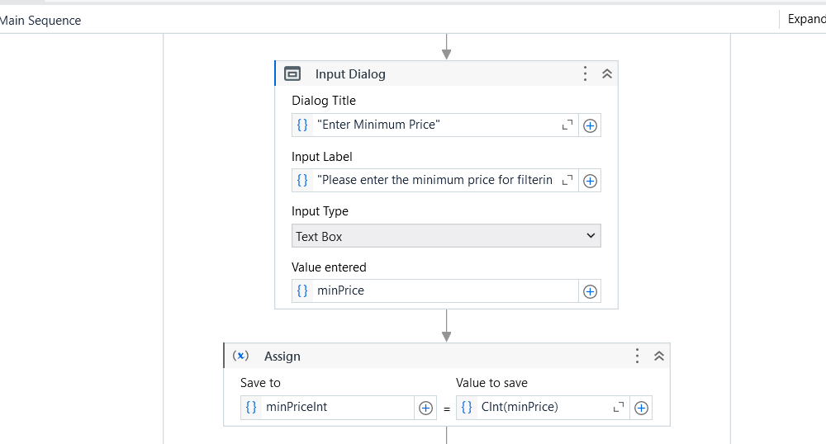

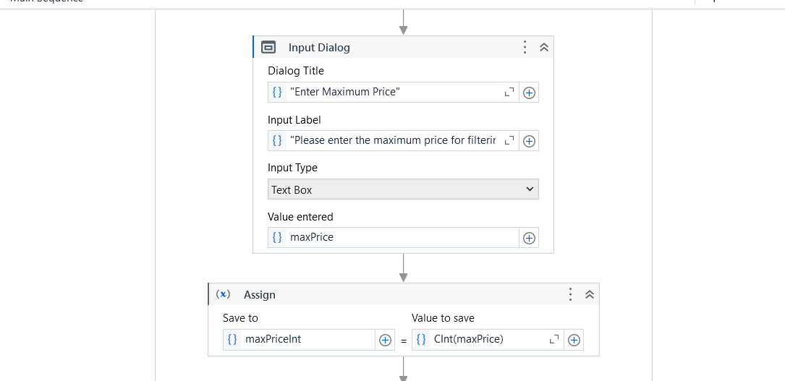

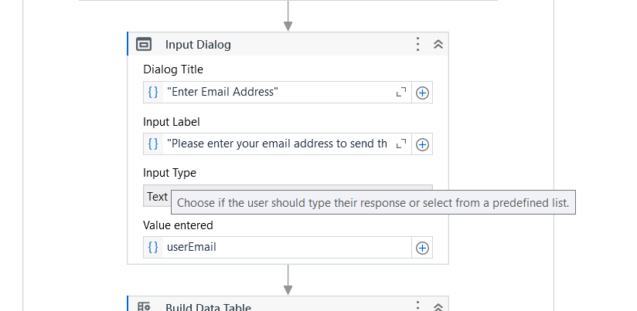

Step 6: Build table for output table (filtered data):
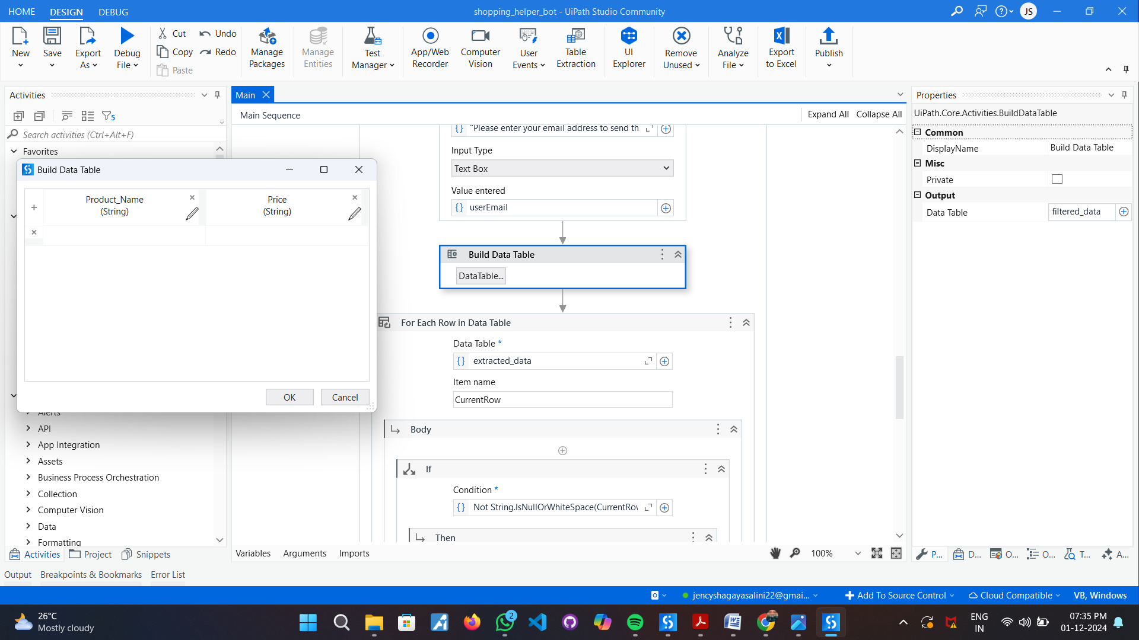

Step 7: Filter Product Data using for each row activity and if activity:
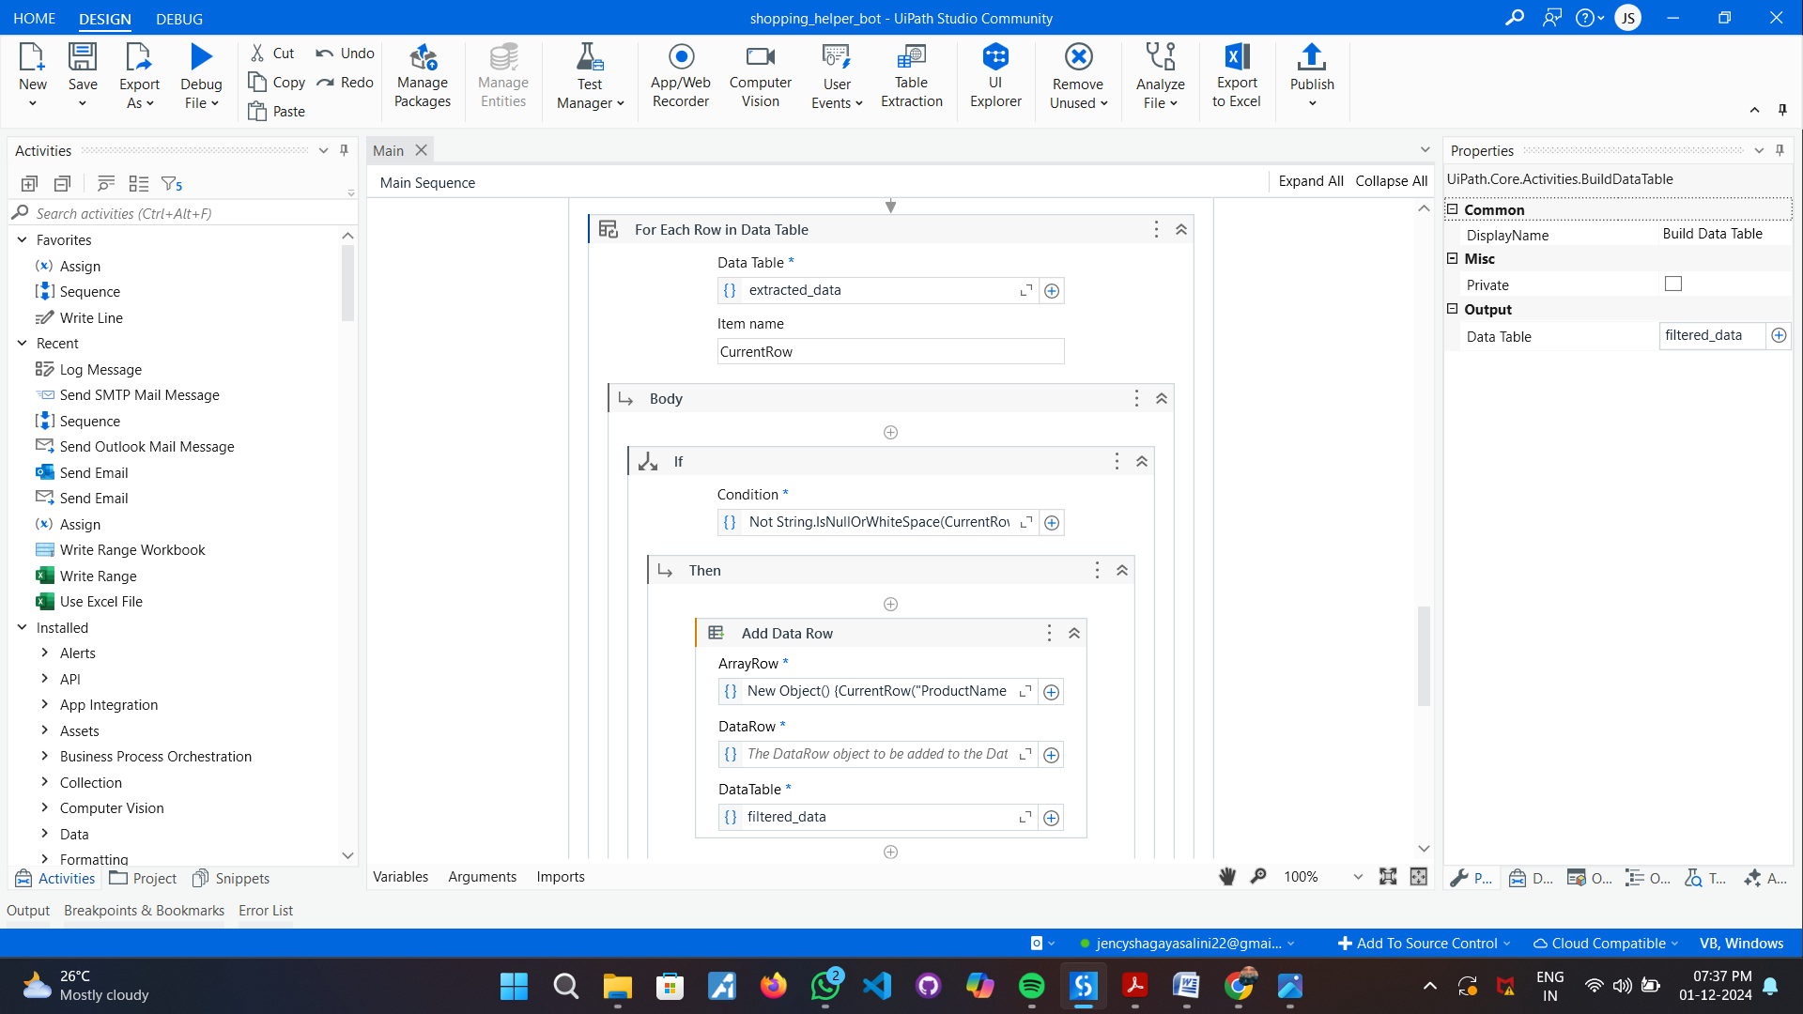

Step 8: Write Data to an Excel File:
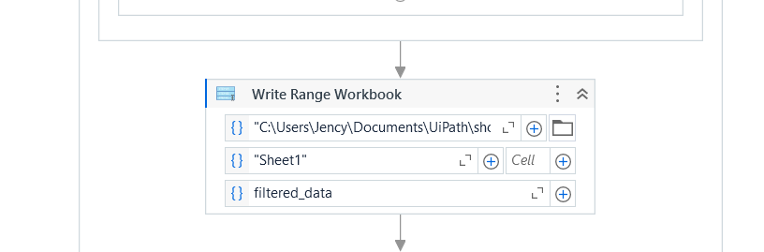

Step 9: Send Email with the Excel File:

Step 10: Add Log Message:


6.OUTPUT SCREENSHOT:

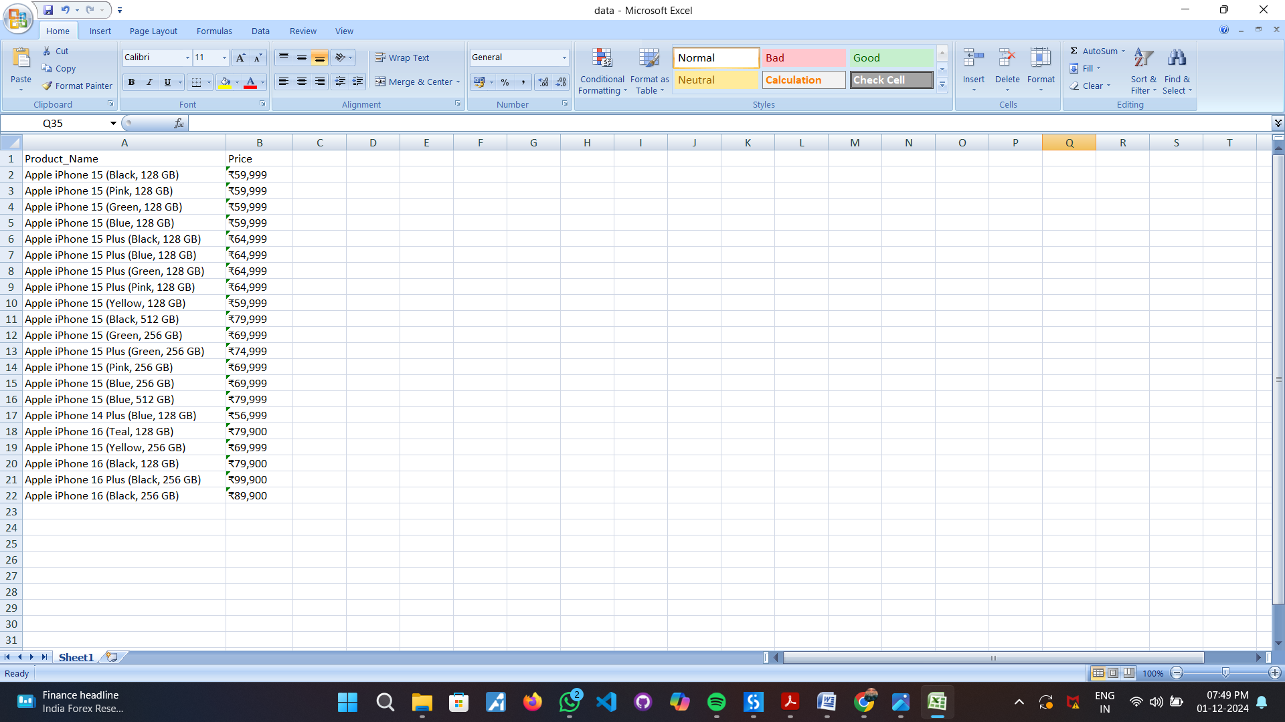

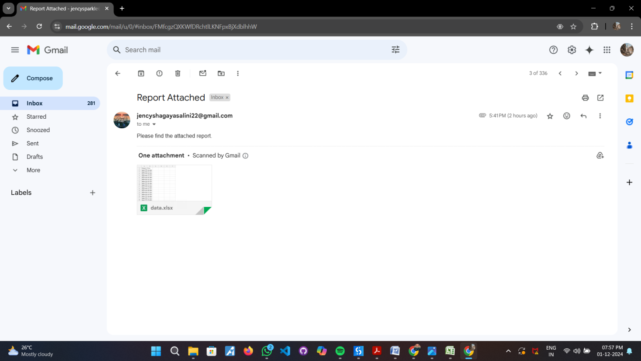

Do’s & Don’ts:
· Do use Excel Modern Activities
· Do use proper naming conventions for variables and arguments.
· Do validate your workflow with Workflow Analyzer and it should have 0 Errors / Warnings.
· Do not give default values use assign statement wherever necessary.
7.WEEKLY SESSION CONTENTS:
Session 1.1 | Introduction to Robotic Process Automation and Building your first automation
Robotic Process Automation (RPA) is a technology that automates business processes by using software robots. This session gives an overview and build the first automation.
Introducing RPA to the participants and walking them through the user interface of UiPath Studio and Orchestrator. By the end of the webinar, participants will have the knowledge and skills to build their first automation project using UiPath Studio.
Understand variable, argument and data manager panel in UiPath

Session 1.2 | Variables arguments and control flow in studio
Topic: Control Flow Activities and Data Manipulation
This course looks to equip you with the proper understanding of how the UiPath Platform works to empower you and your organization for end-to-end automation.
If you don’t have any prior experience in the RPA field, you shouldn’t worry about it. We are listening closely to what our learners are telling us and have shaped the RPA Developer journey so that you’ll be successful.
Through this introductory course, you will learn about the RPA development process and what the RPA developer’s role and responsibility is.Upon completion, you should be able to explain how the core UiPath RPA components work together and how to set up an attended environment, using Studio, Robot with Assistant, and Orchestrator.
Session 1.3 | Automating Web and Desktop Applications with Studio & Data
Manipulation with UiPath
Topic: Mastering UI automation with Modern Design and Debugging
This course looks to equip you with the proper understanding of how the UiPath Platform works to empower you and your organization for end-to-end automation
If you don’t have any prior experience in the RPA field, you shouldn’t worry about it. We are listening closely to what our learners tell us and have shaped the RPA Developer journey so that you’ll succeed.
This introductory course will teach you about the RPA development process and the RPA developer’s role and responsibility.
Upon completion, you should be able to explain how the core UiPath RPA components work together and how to set up an attended environment, using Studio, Robot with Assistant, and Orchestrator.
Session 1.4 | Data Tables and Excel Automation with UiPath
Topic: Excel Automation and Error Handling and Orchestrator
This course looks to equip you with the proper understanding of how the UiPath Platform works to empower you and your organization for end-to-end automation.
If you don’t have any prior experience in the RPA field, you shouldn’t worry about it. We are listening closely to what our learners tell us and have shaped the RPA Developer journey so that you’ll succeed.
This introductory course will teach you about the RPA development process and the RPA developer’s role and responsibility.
Upon completion, you should be able to explain how the core UiPath RPA components work together and how to set up an attended environment, using Studio, Robot with Assistant, and Orchestrator.

Session 1.5 | Debugging exception handling and logging in Studio
Session 1.6 | Email and PDF Automation
Session 1.7 | Orchestrator Overview, Version Control Systems

Session 1.8 | Naan Mudhalvan Projects & Project Organization, RPA Testing

1. Random User API | 2. Bank Loan Id Generation
3. Dynamic Web Form Data Entry | 4. Password Reset Bot
5. Encrypt And Decrypt Files | 6. Move and Rename
7. Integrating Python for Monthly Expenses Analysis | 8. Ticket Data Extracter BOT
9. Invoice Data Extraction | 10. Shopping Helper BOT
11. Patient Details Registration | 12. PDF Splitter BOT
13. Pivot table for Highest and Lowest Population | 14. Birthday BOT
15. Consolidated Data Reporting using Linq | 16. Student Result Generation
17. Let AI do the copy paste | 18. Loan Apply Utility Bot
19. Automated Mail Invitation System for Symposiums and other events | 20. Document Templating for Academic Adminidtration

8.DIPLOMA CERTIFICATE:
Naan Mudhalvan robotic process automation Foundation Course Link:
https://academy.uipath.com/learning-plans/naan-mudhalvan-robotic-process-automation- foundationcourse-for-engineering
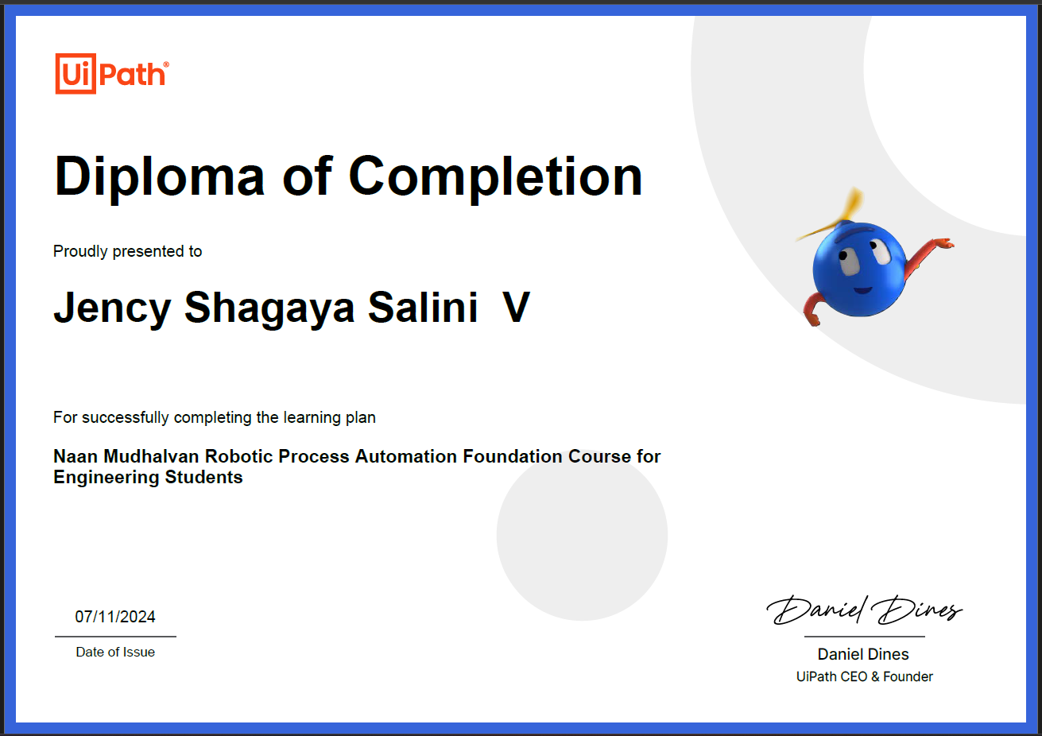

9.CONCLUSION:
The Shopping Helper Bot project successfully aimed to enhance the online shopping experience by offering personalized product recommendations, efficient search capabilities, and real-time price comparisons. By using natural language processing, the bot helps users easily find products, track orders, and receive notifications for discounts. This streamlined approach saves time and improves customer satisfaction. Moving forward, features like voice integration, multilingual support, and more advanced AI for deeper personalization could further enhance its utility, making it an indispensable tool for both consumers and e-commerce platforms.

10.REFERENCES:
- https://docs.uipath.com/studio/docs/introduction
- https://docs.uipath.com/studio/docs/the-user-interface
- https://docs.uipath.com/studio/docs/creating-basic-process
- https://academy.uipath.com/courses/variables-and-arguments-in-studio
- https://docs.uipath.com/studio/docs/the-variables-panel
- https://docs.uipath.com/studiox/docs/managing-your-project-data
- https://docs.uipath.com/studio/docs/about-control-flow
- https://www.uipath.com/learning/video-tutorials/control-flow
- https://docs.uipath.com/studio/docs/managing-variables

